Minidoka Schools Speech and Poster Contest 2026
Sponsored by Minidoka Soil and Water Conservation District
98 South 200 West Suite B Rupert Idaho 83350. 208 436 4202
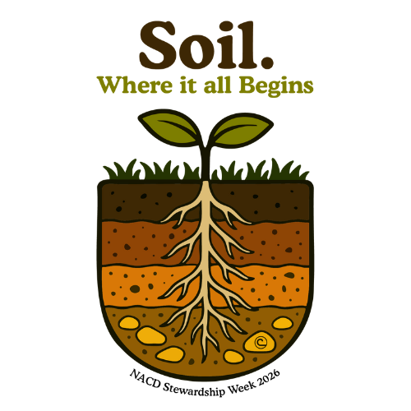
Poster and Speech contest Theme: Soil. Where it all Begins. Must be included in your presentation
Poster Contest 2026 for 5-6 grades in Minidoka County.
1.Posters MUST be on 14x22 inch poster board (we provide one per student)
2. Any media may be used to create a FLAT depictions of the theme (paint, crayon, colored pencil, computer generated artwork or other material)
3. ALL work must be done by the student. (Parents and teachers may offer support and planning ideas only)
4. The theme SOIL. WHERE IT ALL BEGINS. Must be on the front of the poster. Students FULL name must be on the back of the poster. Along with the teachers name and the school.
5. Turn in posters to teachers by the 7th of October 2026 to be. Judged by the Soil and Water Conservation District.
6.Poster will be judged on Conservation message, visual effectiveness (can words be seen 10 feet away), orginality, and universal appeal.
7. There will be 3 top winners from each school, The top 3 winners will advance to District judging. The top 3 winners from District will advance to Division IV competition. The top 3 winners from Division IV will be sent ot The Idaho State Soil and Water Conservation competition.
8. Awards per school will be presented in November before Thanksgiving break.

Minidoka Schools Speech and Poster Contest 2026
Sponsored by Minidoka Soil and Water Conservation District
98 South 200 West Suite B Rupert Idaho 83350. 208 436 4202

Speech Contest 2026 theme: SOIL. WHERE IT ALL BEGINS. OCTOBER 20, 2026, 6:30 p.m.
Conference room at the Conservation District office

RULES:
- Contestants must be high school students grades 9-12 in September of 2026 in Minidoka County
- Any prior state winner is not eligible as a contestant.
- Schools and or classes shall send no more that 5 students each
- Each contestant must fill out and submit an application form, (these can also be found on the webpage www.minicassiaswcd.com under Educational programs tab.
- The speech shall be at least 3 minutes and not more than 5 minutes, including the salutation and title. Contestants will NOT give their name or any family name at any time during their speech. No props or visual aids will be allowed.
- Speech must be contestant’s original text, researched and written by the contestant. Content must address the theme Soil. Where it all Begins. Notes will be allowed at the district level only.
- There shall be 3 judges and a timekeeper. Money prizes will be awarded to the top 3 contestants form the district. 1st place $100.00, 2nd place $75.00 and 3rd place is $50.00
- District event will be October 20th at 6:30 p.m. in the conference room at the Minidoka office 98 South 200 west suite B – Rupert (across from the Rupert Elks)
- The top winner from the district will be invited to compete for prizes at the Division IV speech contest to be held November 5th place to be announced. The winner from Division IV will be invited to participate in the State Contest in Moscow Idaho most likely on the evening of November 17th.
- Tips for preparing your speech:
  - Highlight the benefits of soil and water conservation
  - Address how conservation has improved people’s lives
  - Dress in a professional manner
  - Use the theme
  - Include information in your speech that is important to you
Minidoka Soil and Water Conservation District
Education Speak – off competition
2026 theme:
SOIL. Where it all Begins
Application for Minidoka high school students grades 9-12

NAME_____________________________________________________________________________age ________

Address _______________________________________________________________________________________

City ____________________________________________ zip ______________ phone ______________________

High School __________________________________________ grade ___________________________________

Parents: _______________________________________________________________________________________

Club affiliations: _______________________________________________________________________________

Briefly state your interest in conservation or agriculture practices _______________________________

__________________________________________________________________________________________________
__________________________________________________________________________________________________

To reserve your spot please call 208 436 4202, Minidoka Soil and Water Conservation District. Speech contest date is Tuesday October 20th at 6:30 p.m. at 98 South 200 West in the conference room -Rupert Idaho 83350, white brick building across from the Rupert Elks.

